**To** Bruce Bolden

**From** Tao Zhang

**Subject** Java SE 7u51 Installation Report

**Introduction**

Here are the results for the installation of Java SE 7u51 on my Windows7 x64.

**Overview**

Get into the Java Home webpage by the address provided on the assignment sheet, find the specific accesses to download “jdk-7u51-windowsx64.exe”. Install it.

Go the tutorials page. Scan the “Trails Covering the Basics”.

I test the sample programs on NetBeans IDE.

**Summary**

Everything is running fine. Java SE 7u51 is successfully installed on my Windows. The tutorial is easy to follow. All the sample programs successfully run on NetBeans.

**Appendicies**

This is the installation file I found on Java webpage.

C:\Users\张涛\Desktop\CS 324\9C5E[UICD(HQ9UWVMYPX%%4.jpg

The directories after installation.

C:\Users\张涛\Desktop\CS 324\NP[I(NSSUAIK6]K8{YX}(CC.jpg

The output of sample programs on NetBeans IDE.

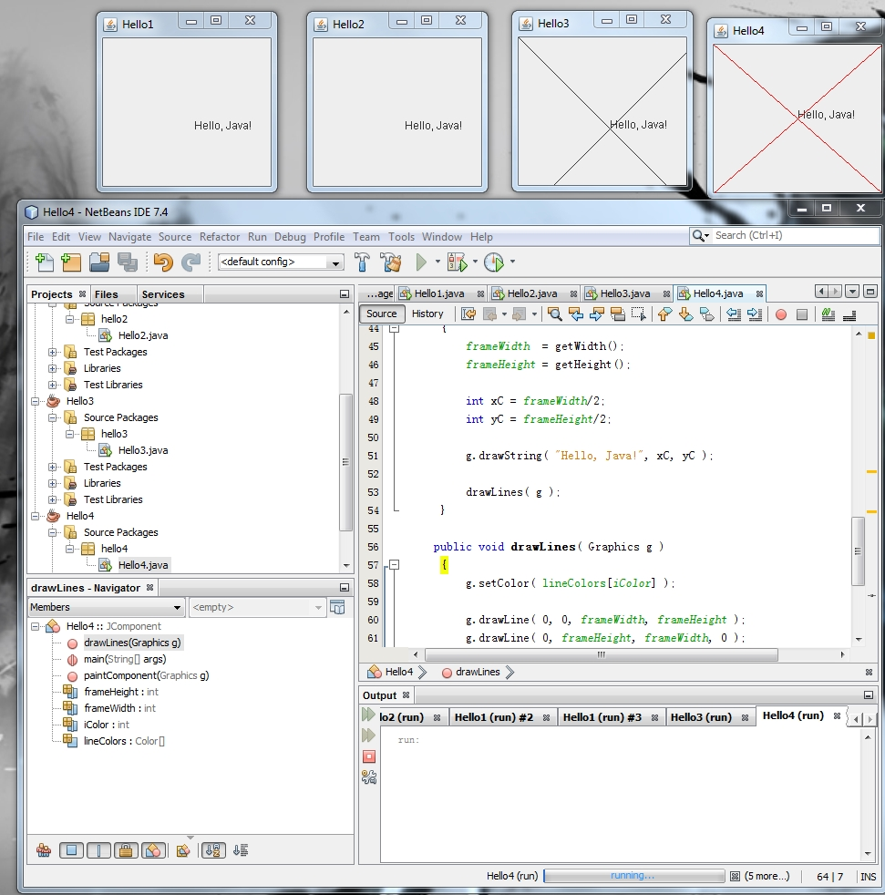

Nothing else to report.